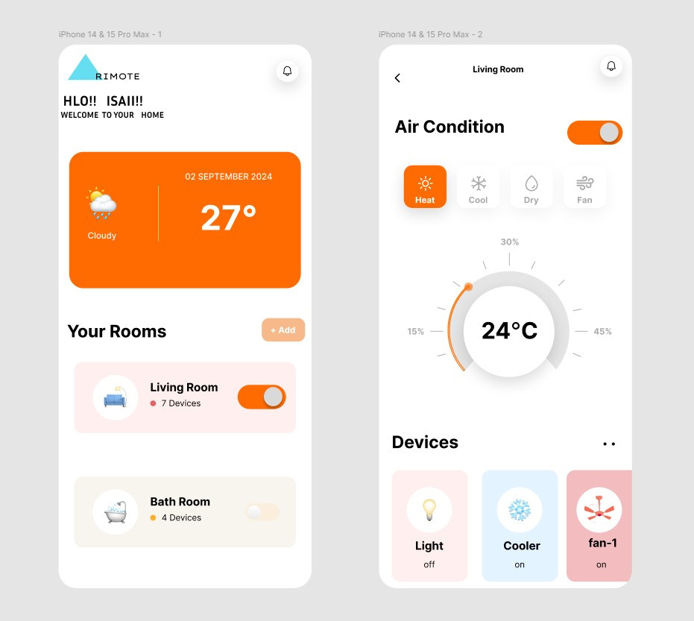

**rimote**

**Aim:**   
To develop a simple TV remote control app that allows users to control their TV through their smartphones.

**Procedure:**

1. **Identify Supported Devices:** Ensure the app supports various TV brands and models (e.g., Samsung, LG, Sony).
2. **Choose Technology:**Use Wi-Fi or Bluetooth to connect the app to the TV.
   * For Wi-Fi, implement protocols like DLNA or Smart TV APIs.
   * For Bluetooth, pair the phone with the TV.
3. **Design UI/UX:** Create a clean and intuitive interface with buttons for common functions (power, volume, channels, input selection).
4. **Develop the App:**
   * For Android: Use Java/Kotlin and Android APIs for Bluetooth/Wi-Fi control.
   * For iOS: Use Swift and appropriate libraries for TV control.
5. **Testing:** Ensure compatibility with multiple TV models and conduct usability tests.
6. **Launch:** Release the app on app stores after bug fixes and final testing.

**Result:**   
A fully functional TV remote control app that allows users to control their TV through their smartphones, featuring essential functions such as power on/off, volume control, channel selection, and input switching.